How to change doortmat (footer navigation)
In this part of the Wordpress manual, you will learn how to edit the website footer navigation.
On the lefthand sidebar scroll to section Appearance, and choose Customise

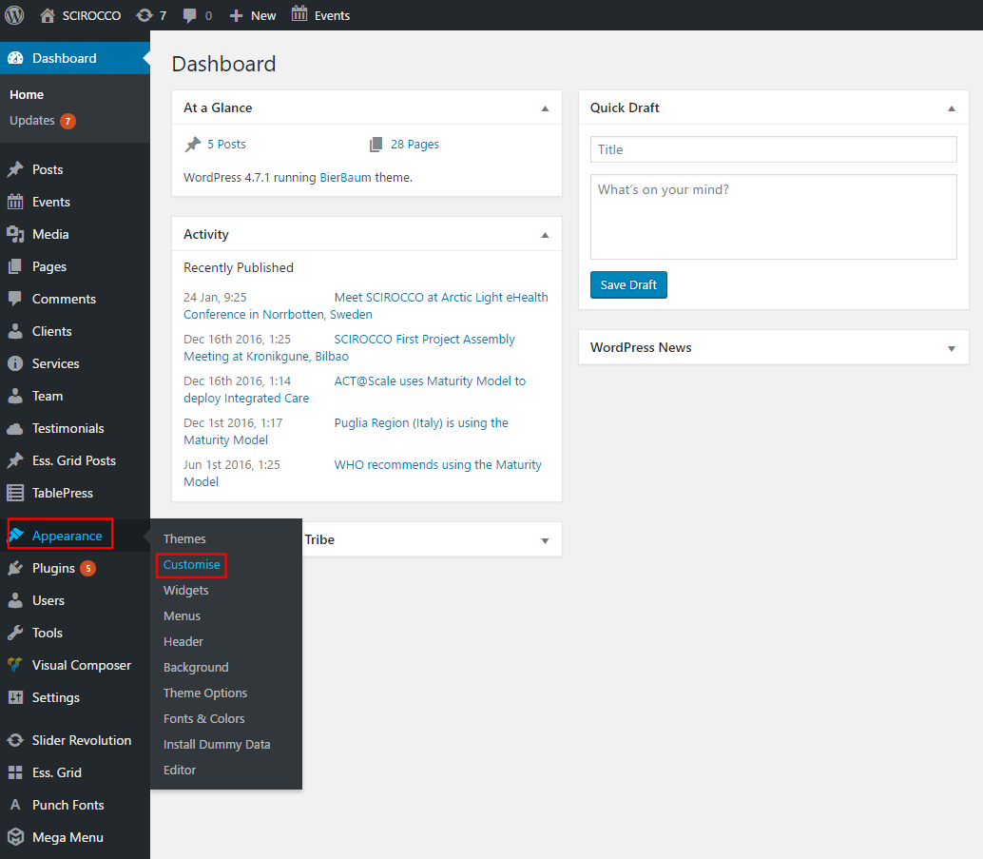

In the Customising section, choose Menus
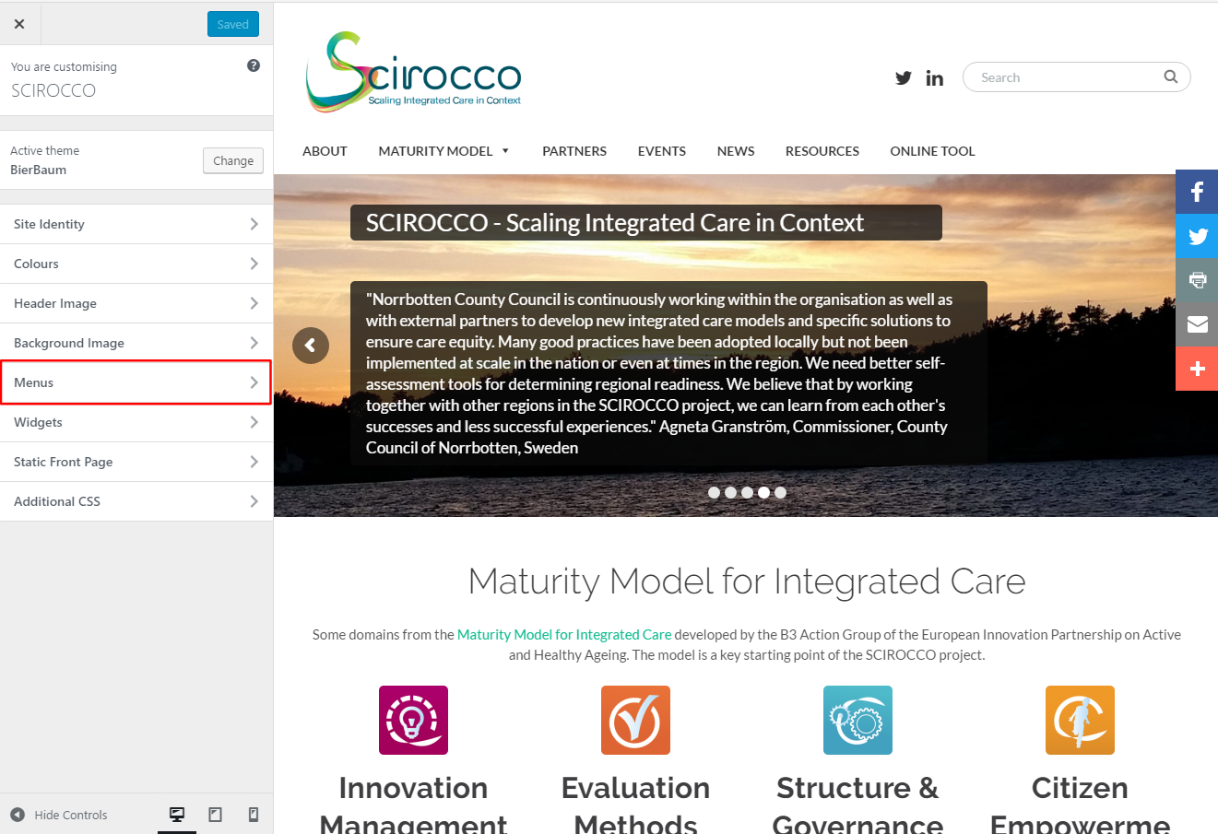

The menu will show all four (4) columns of the Footer navigation columns.
Footer links can be edited either by selecting lefthand menu or visual editor on the bottom.

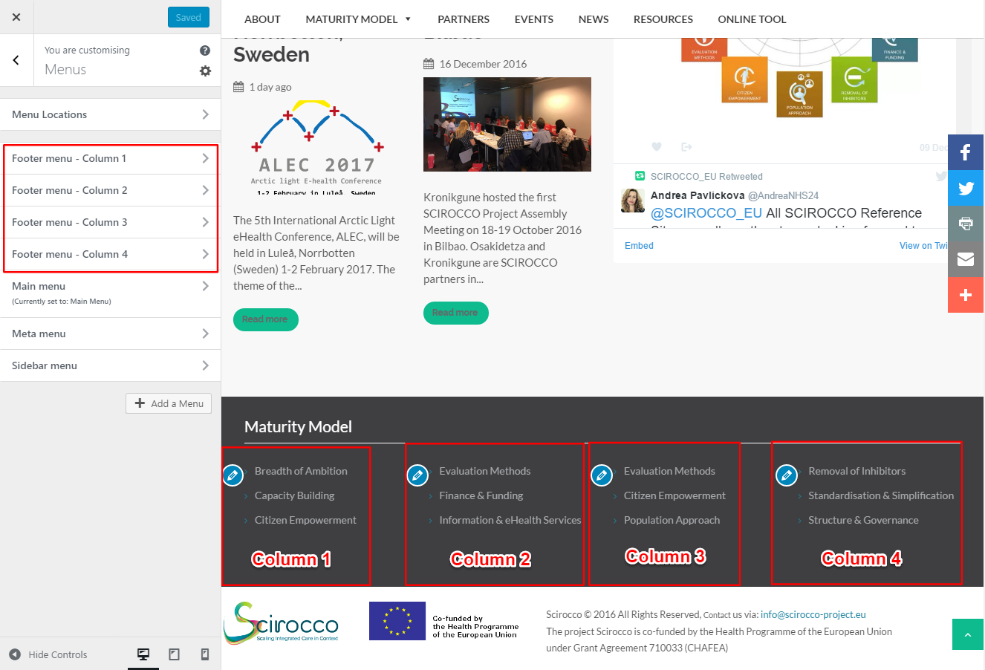

However, you can add a new item (link) by selecting a Column and then clicking button Add Items. Then you can select any page or any post by clicking on their tab on the right.

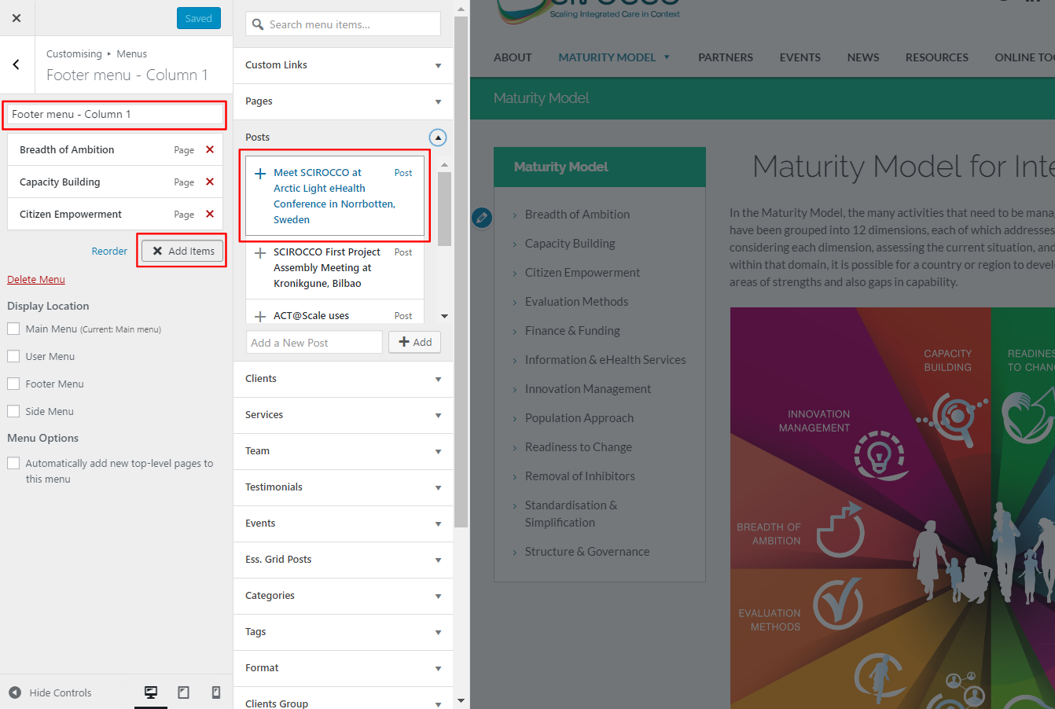

To preview the changes, click Save & Publish

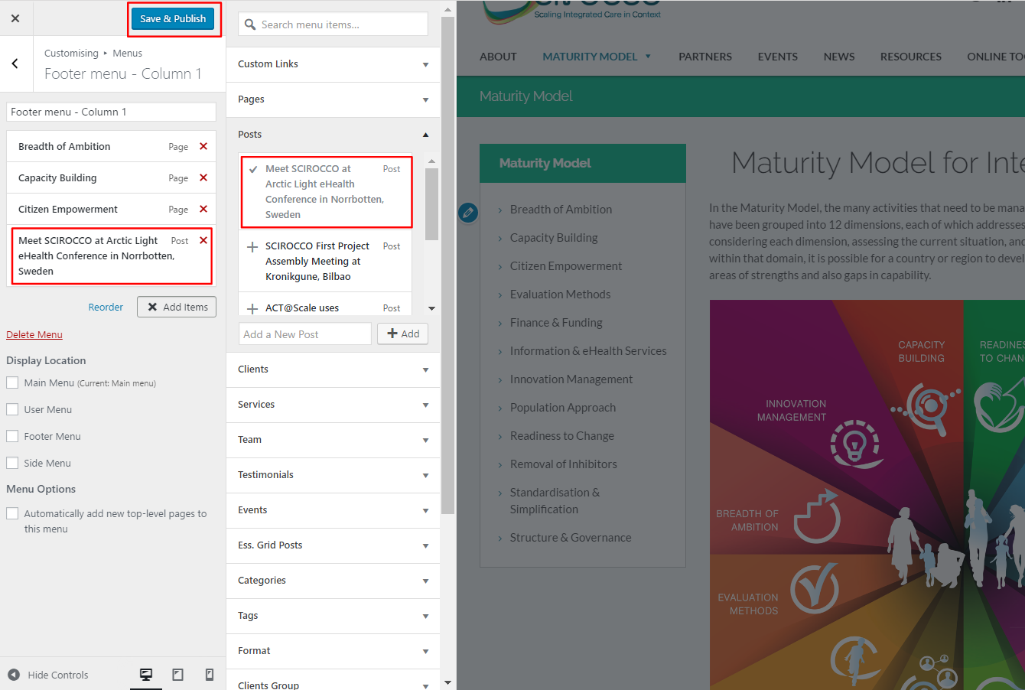

Published changes

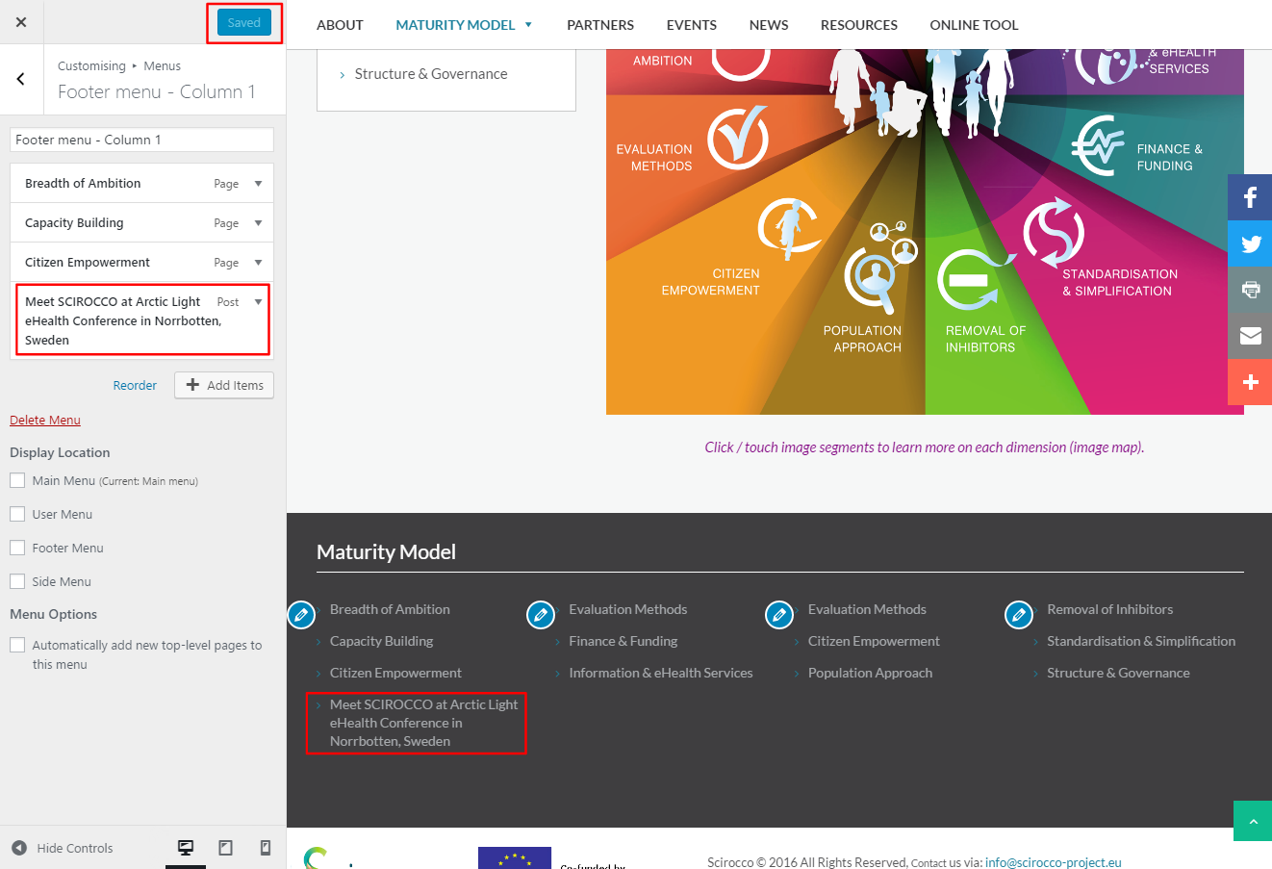

To edit link display text change Navigation Label, and to remove the link, click on button Remove, and Save & Publish to see the changes

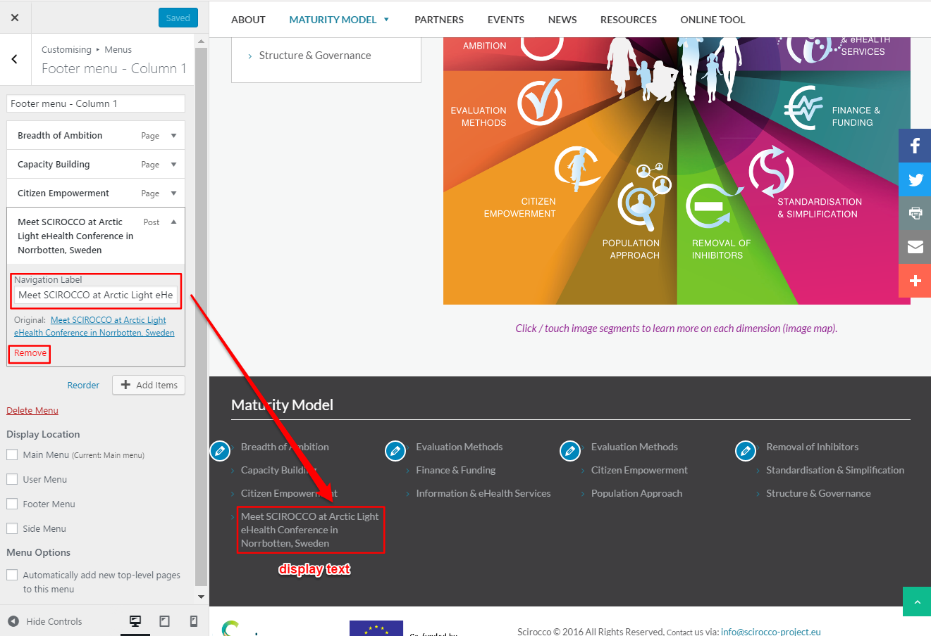

Changing footer contents / structure

You can edit the entire structure and change Title and all links in all 4 columns.

NOTE: Currently, footer navigation is related to Maturity Model section and Sidebar Menu, and adding new pages or posts will break the footer logical structure

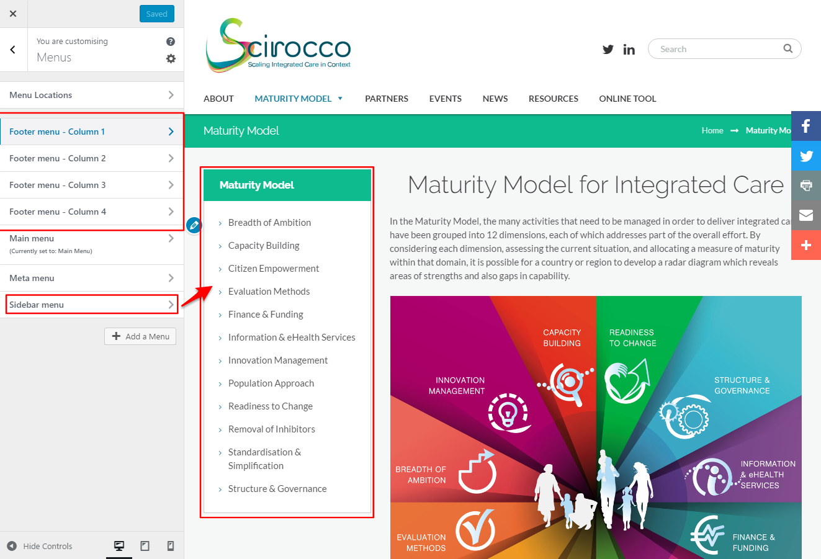

Adding new sections

To add a new section, click on Widgets button

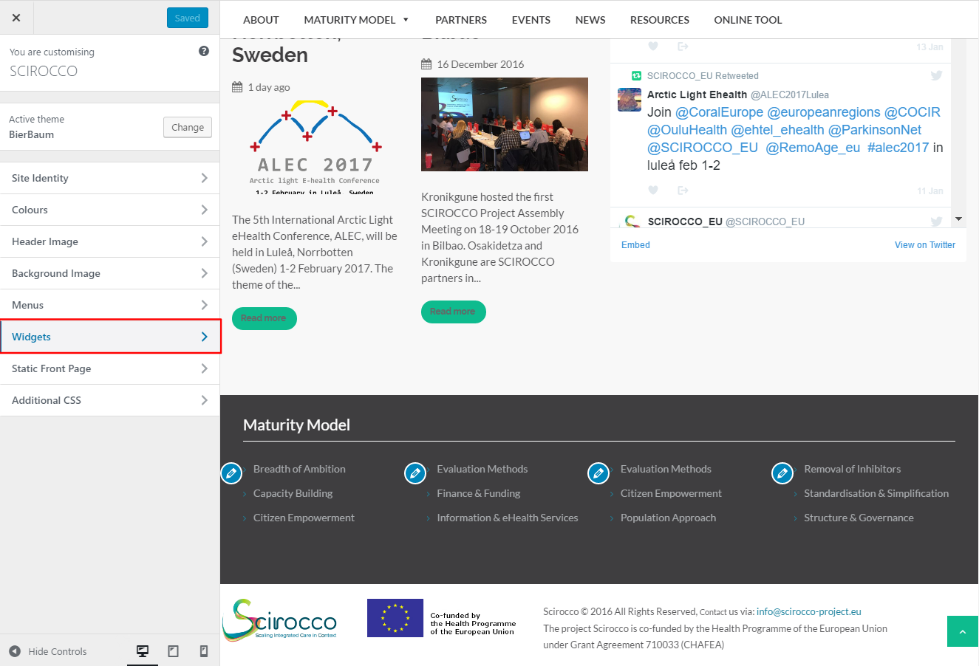

Next, click on Footer Sidebar and then choose Add a Widget

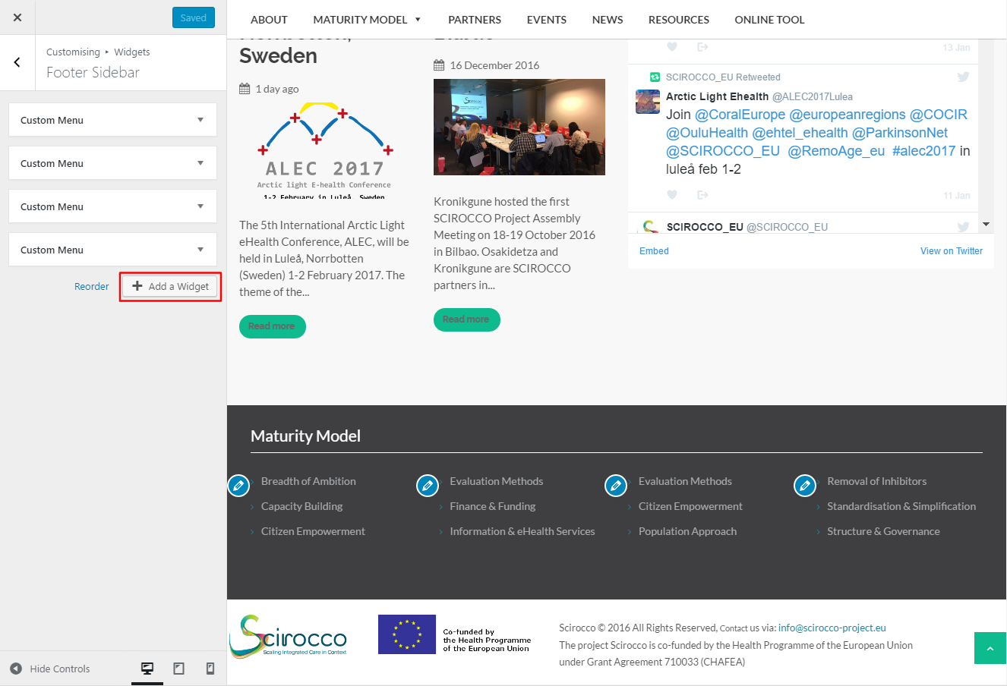

On the right choose any type of element you want to add, for example Post Categories
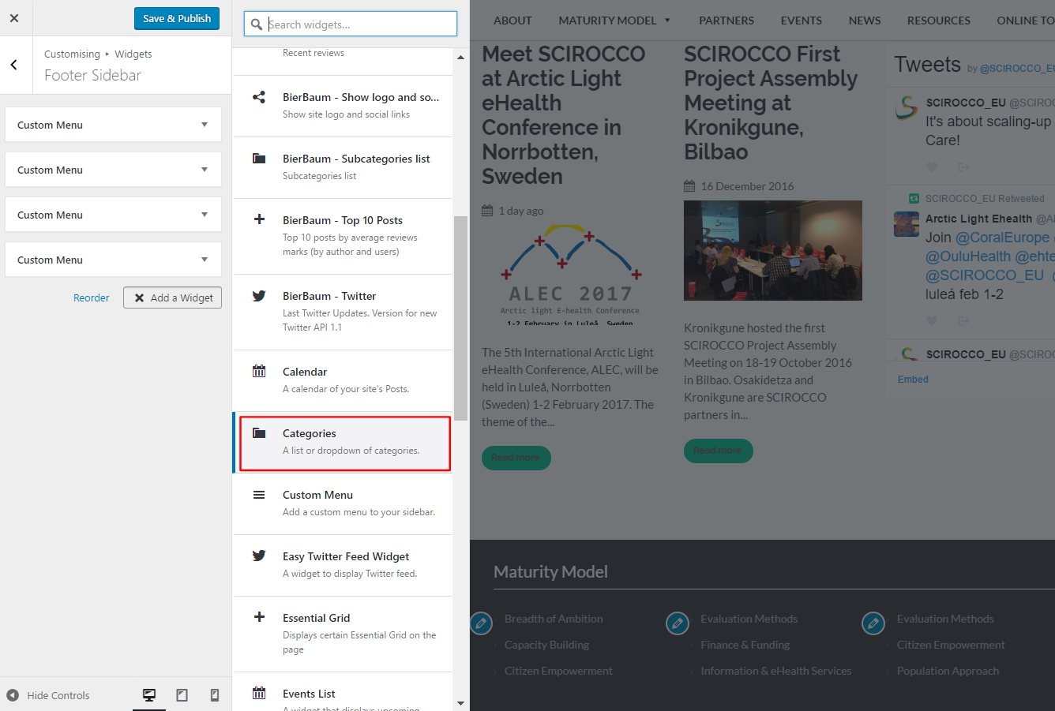

Content editor will open and as soon as you add something, it will appear in the preview panel on the right.
Note: changes will not be visible on the live website until you click on Save & Publish button on the top

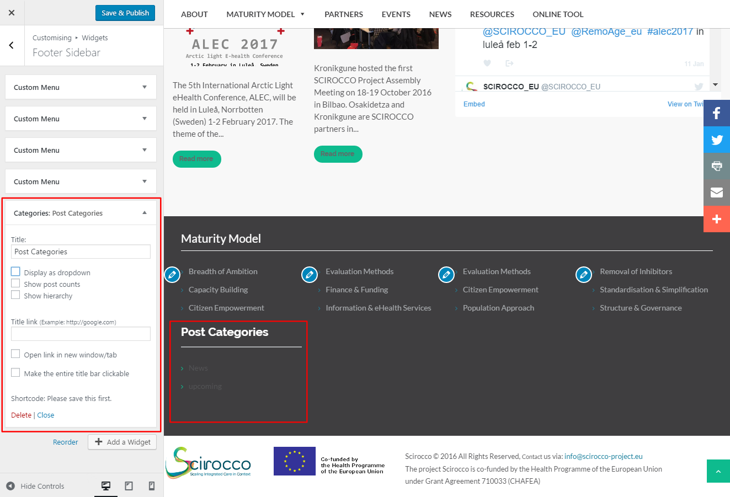

More sample content

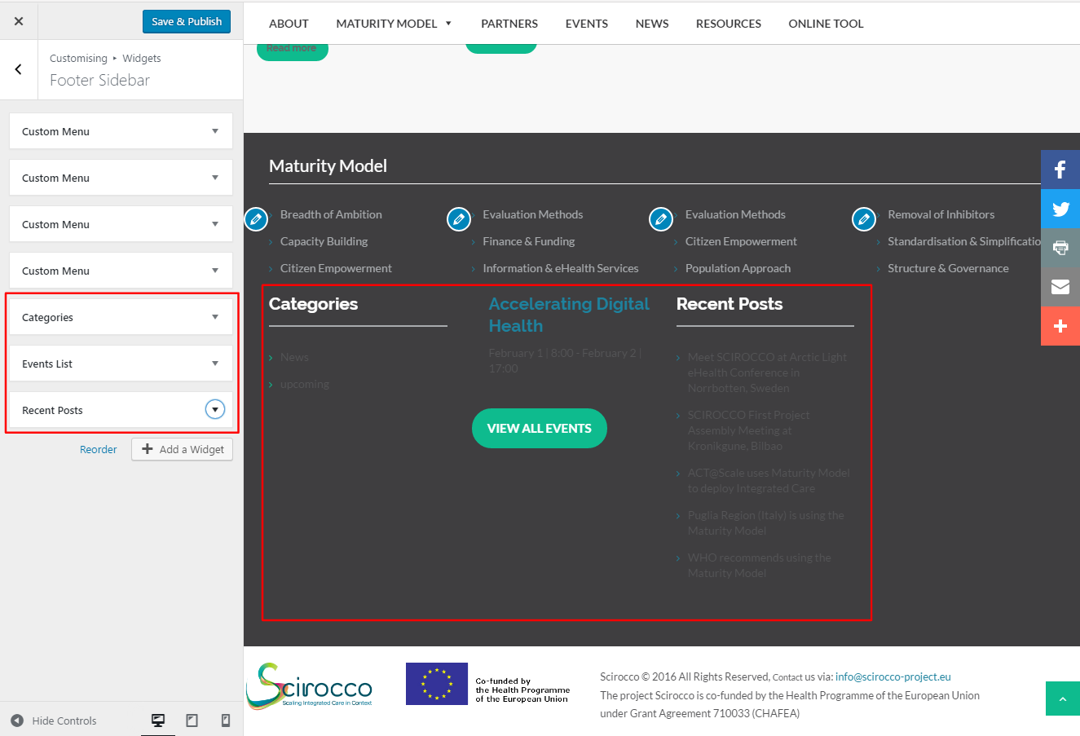

Editing current Footer Title

To change current footer title (Maturity Model) click on Appearance > Widgets > Arbitrary > Text and change only title in HTML Maturity Model. Leave other options intact.

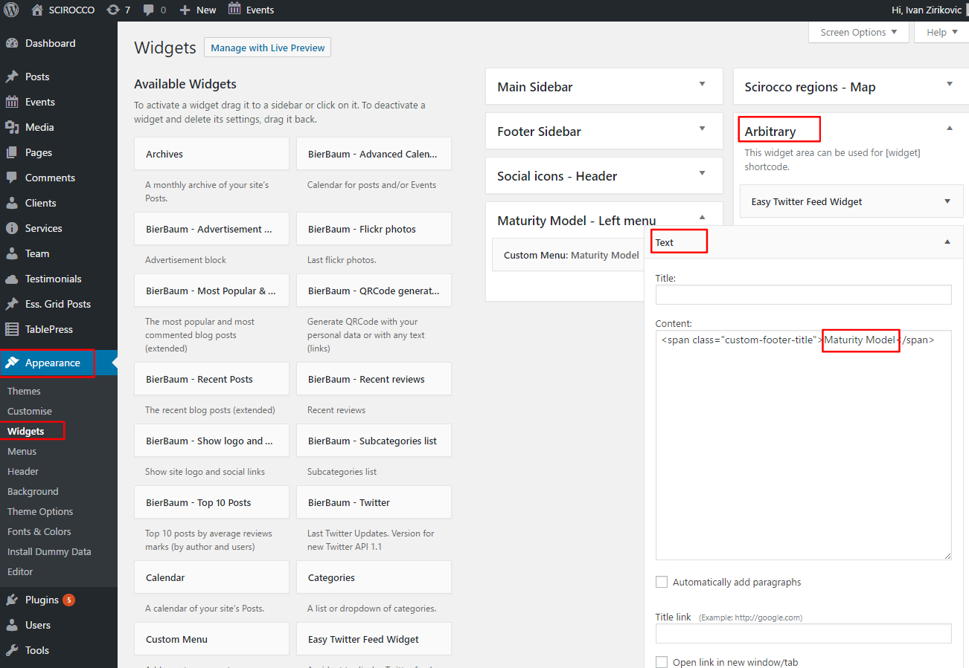

For example - in backoffice editor add New Title

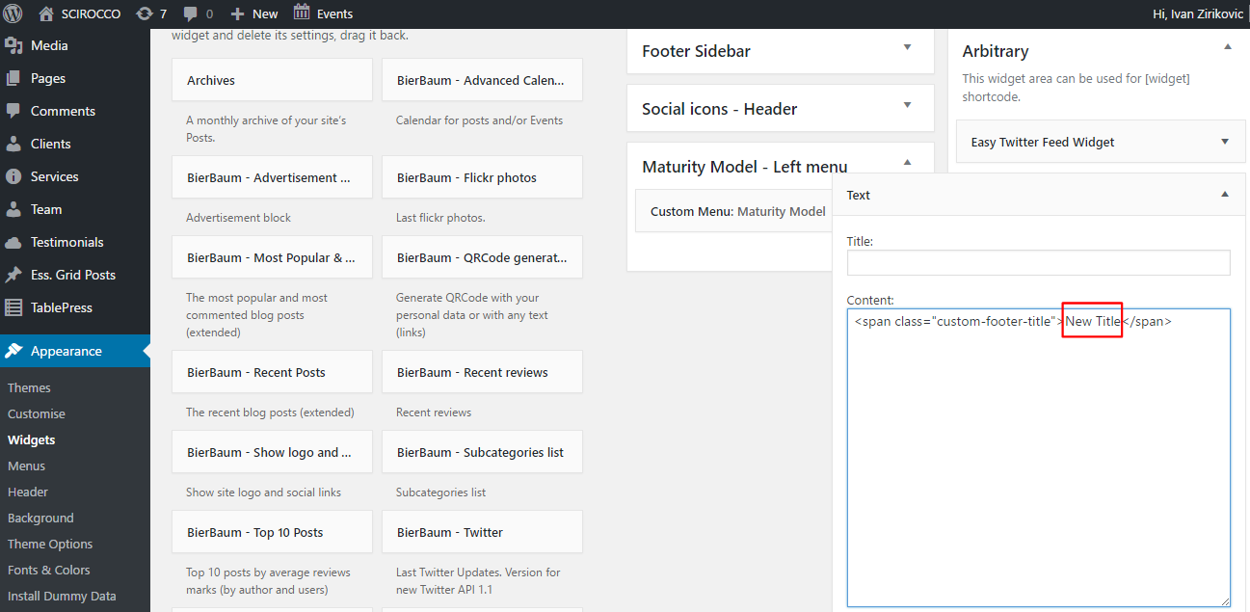

On website it will be changed
