How to change footer (last stripe)
In this part of the Wordpress manual, you will learn how to edit the website footer.
On the lefthand sidebar scroll to section Appearance, choose Theme option and then select Footer

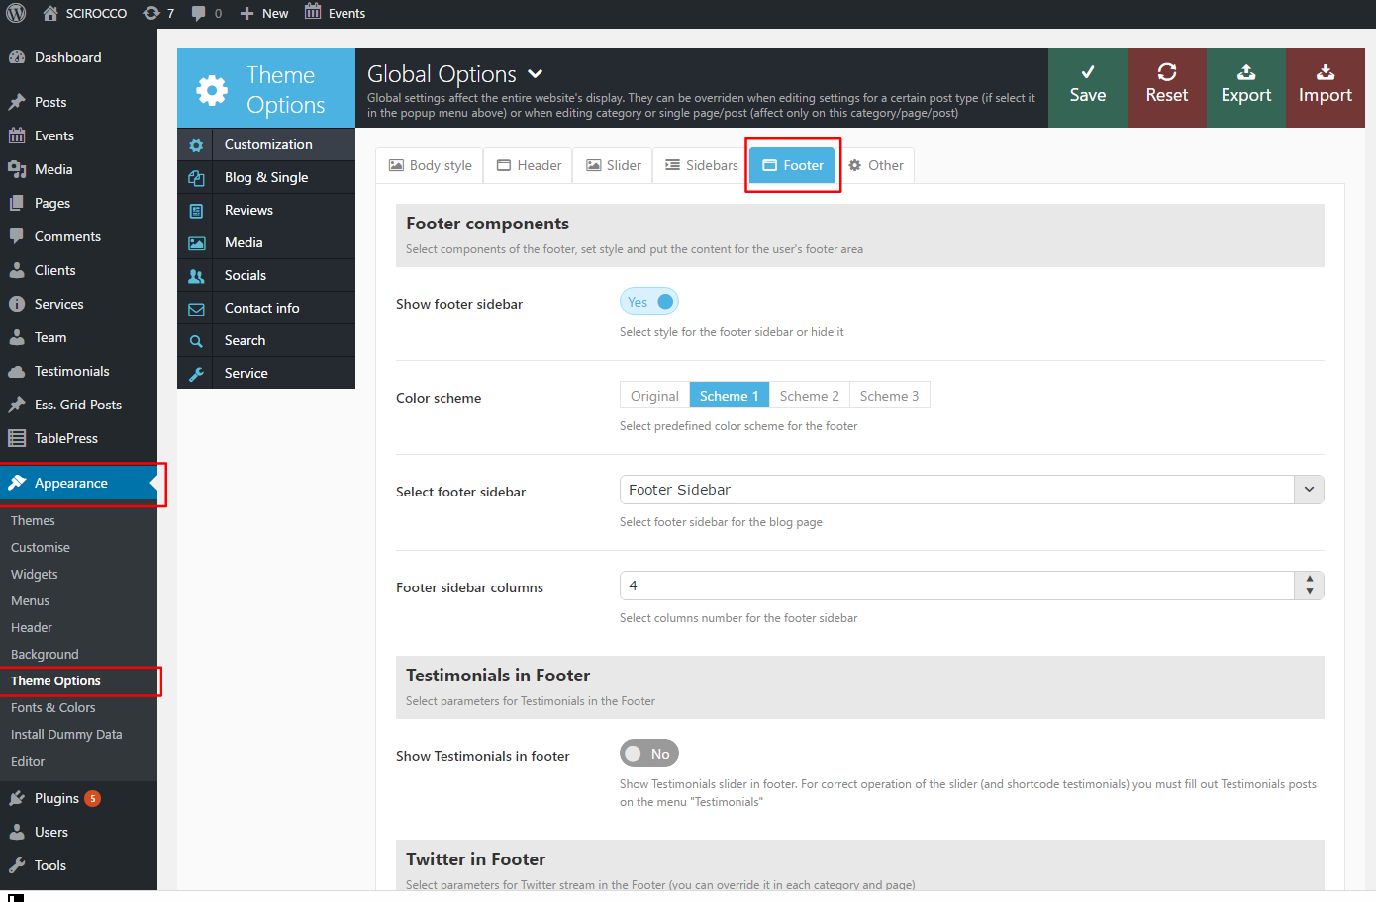

Scroll to the bottom of the page, section Copyright and footer menu.
In the Footer copyright text field add new content or edit the existing one. Once you're done, click Save on the top of the page.

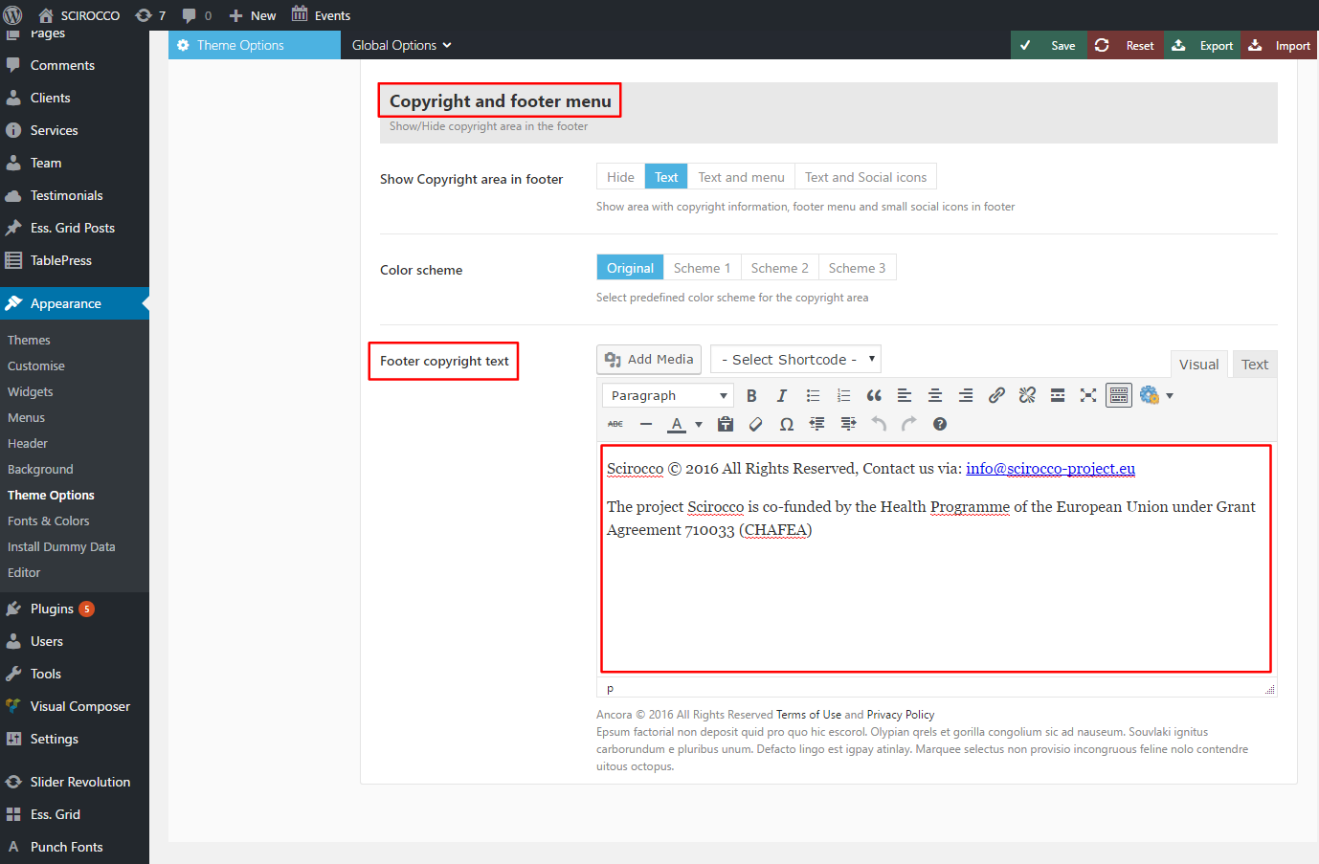

The contents of that section can be previewed on the bottom of the website.

To change the logo, go to Appearance > Widgets > Arbitrary > Image Widget and click on Select an Image button. Click Save to see the changes

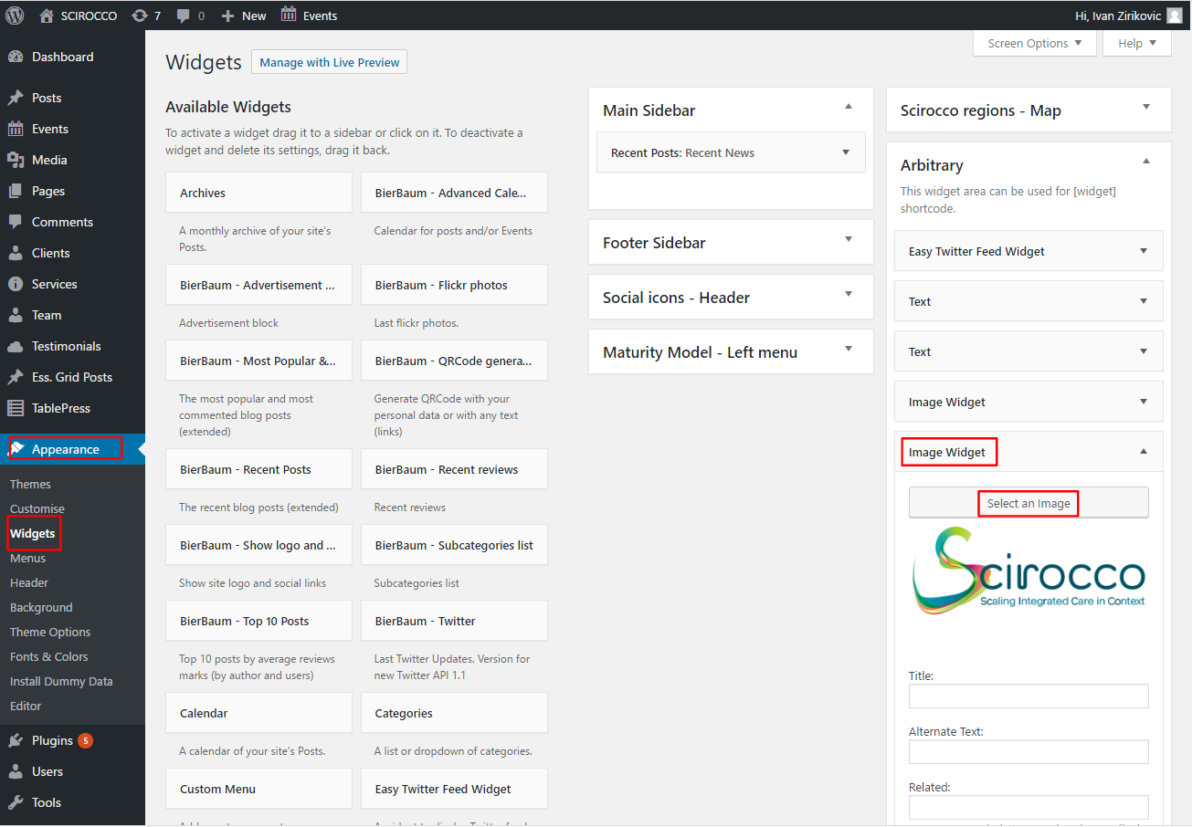

To change EU flag image, go to Appearance > Widgets > Arbitrary > Image Widget and click on Select an Image button. Click Save to see the changes

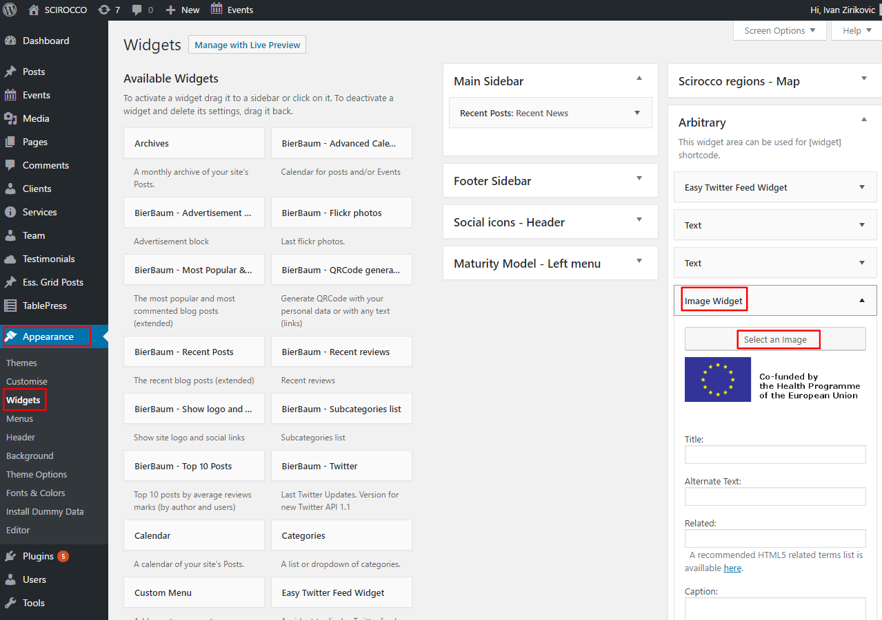

The contents of that section can be previewed on the bottom of the website

