How to create Mega Menu item description (Main Menu)
In this part of the Wordpress manual, you will learn how to edit the Mega Menu description.

Editing the existing Mega Menu contents
To change current Mega Menu contents for Maturity Model navigation link click on Appearance > Menus > Maturity Model
Hover Maturity Model with a mouse, and when a Mega Menu button appears, click on it to access the settings.

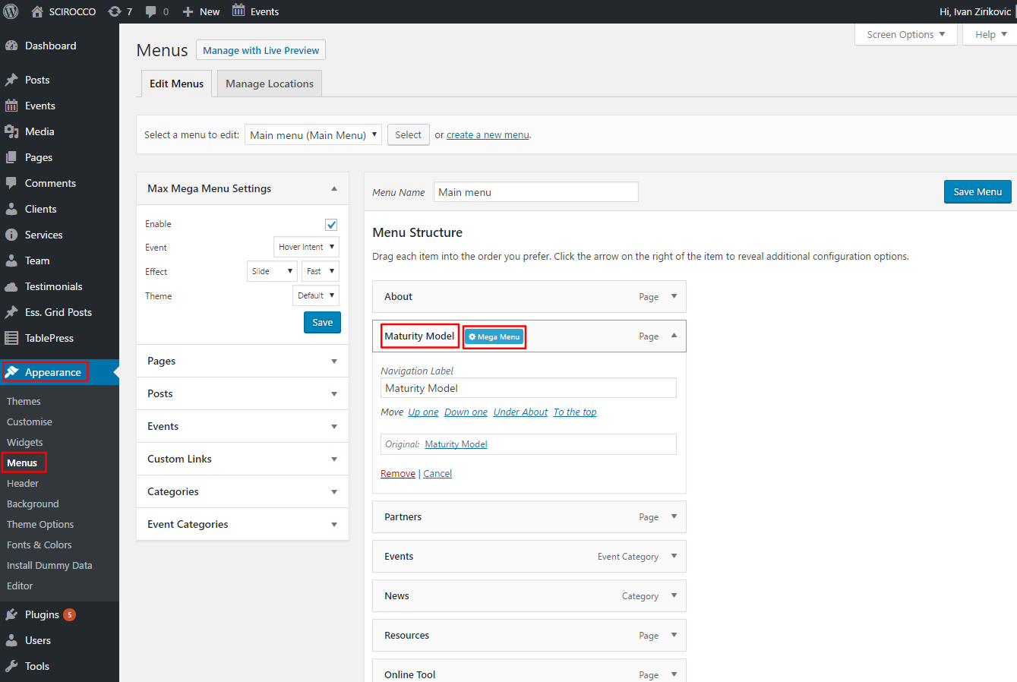

To replace the image, click on the wrench icon on the first box labeled Image Widget

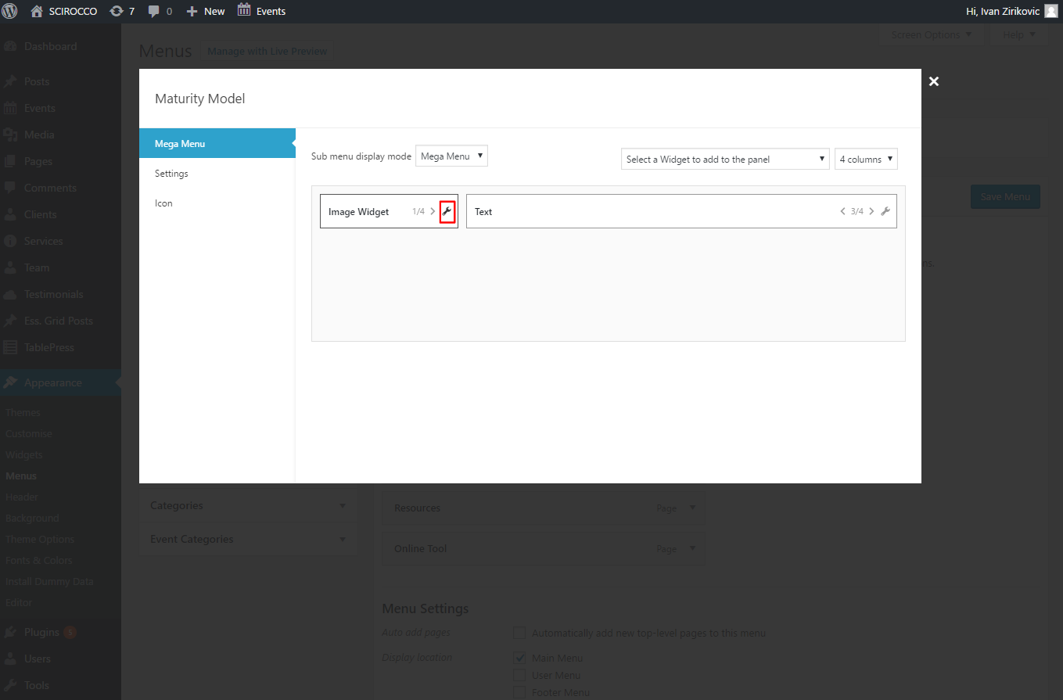

To replace the image, click on Select Image - all other options should be left intact. Once you're finished, click Save on the bottom of the scrolling overlay panel.

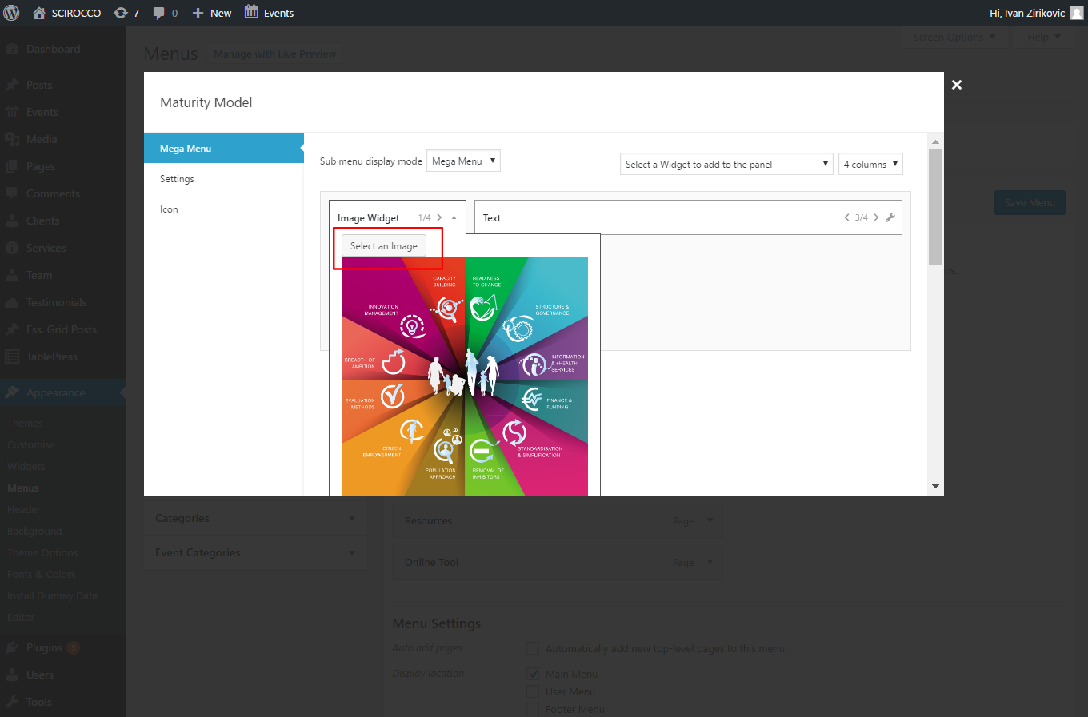

To edit the text beside the image, click on the wrench icon on the second box labeled Text

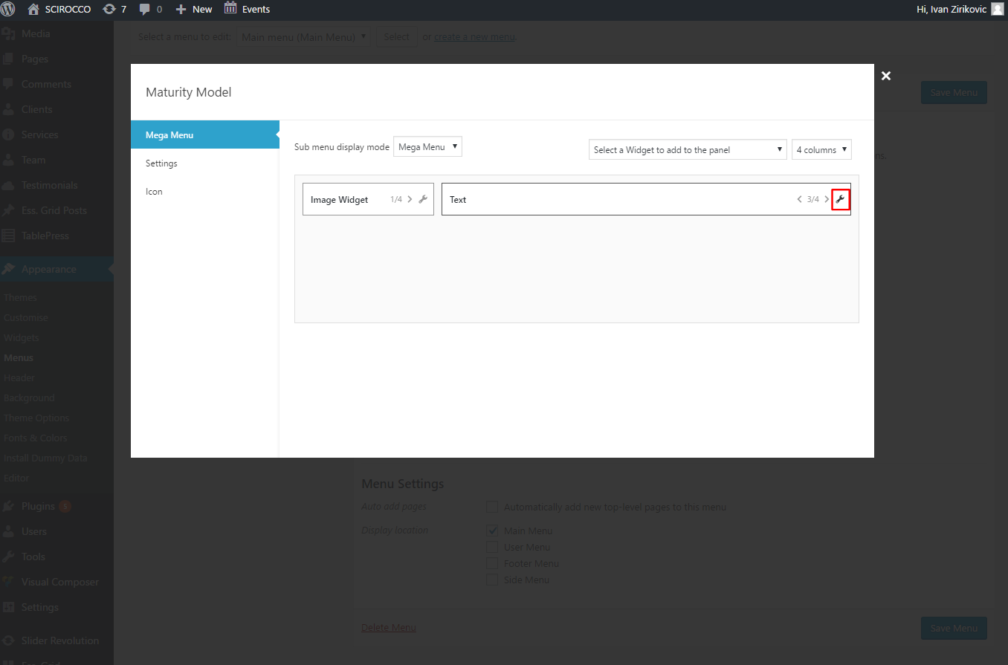

Edit the Content box only, In the Content box you can add other simple HTML tags, such as <a> </a>, or format text, such as adding <b></b> bold tag, etc. Other options / fields should be left intact.
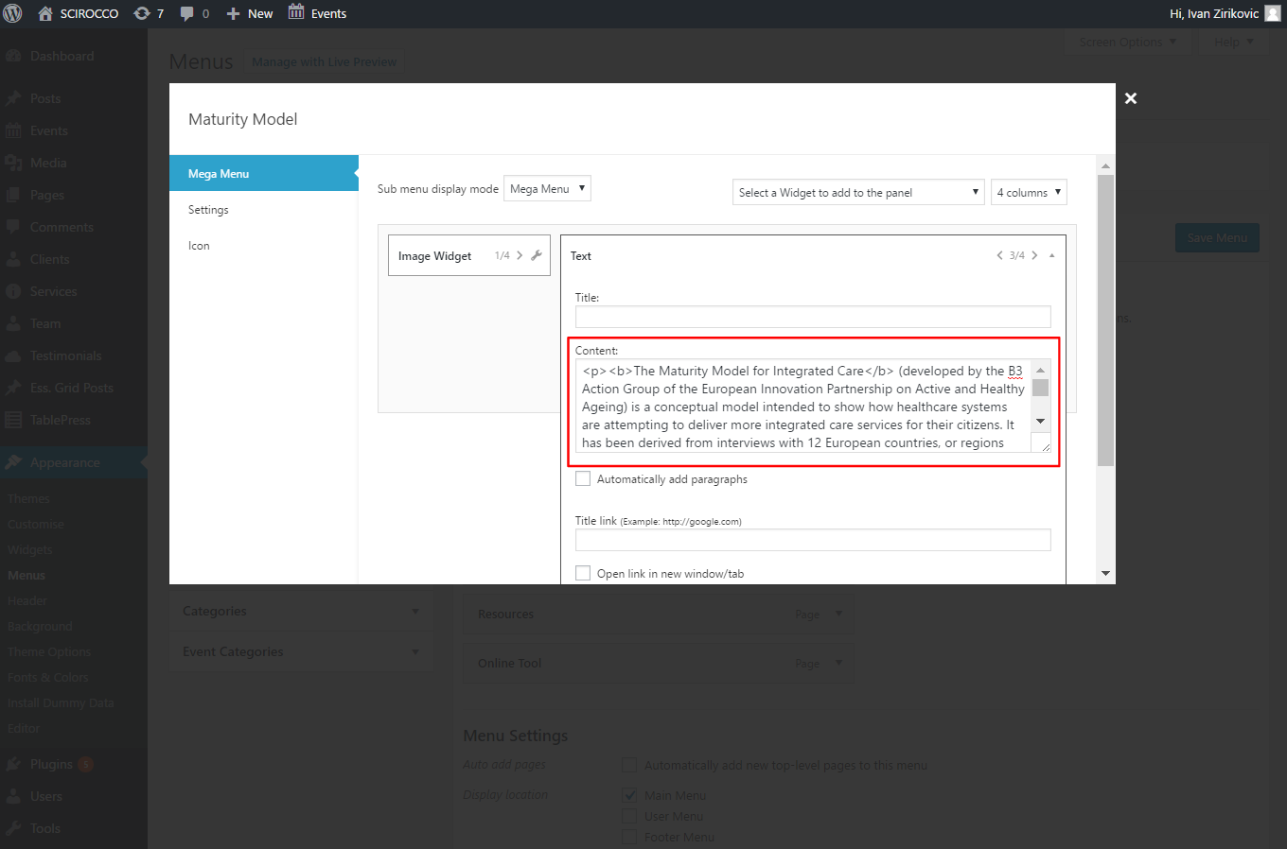

Changes will be visible on the website when you hover the link Maturity Model

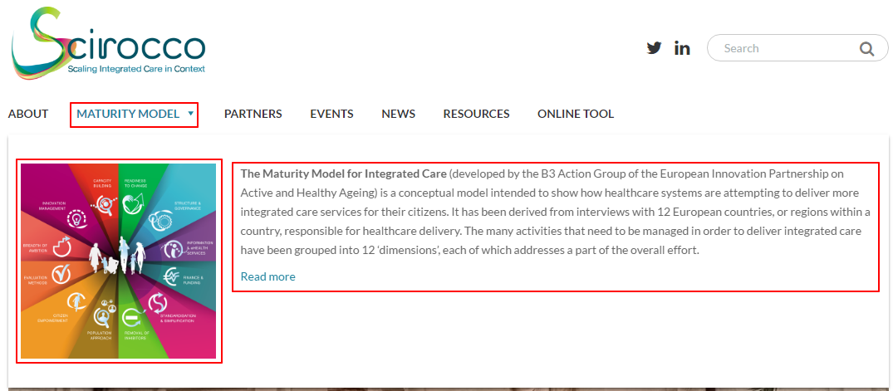

Creating new Mega Menu contents
To add Mega menu description to other Main navigation menu items, hover any of them (e.g. News) and click on the button Mega Menu to access the settings

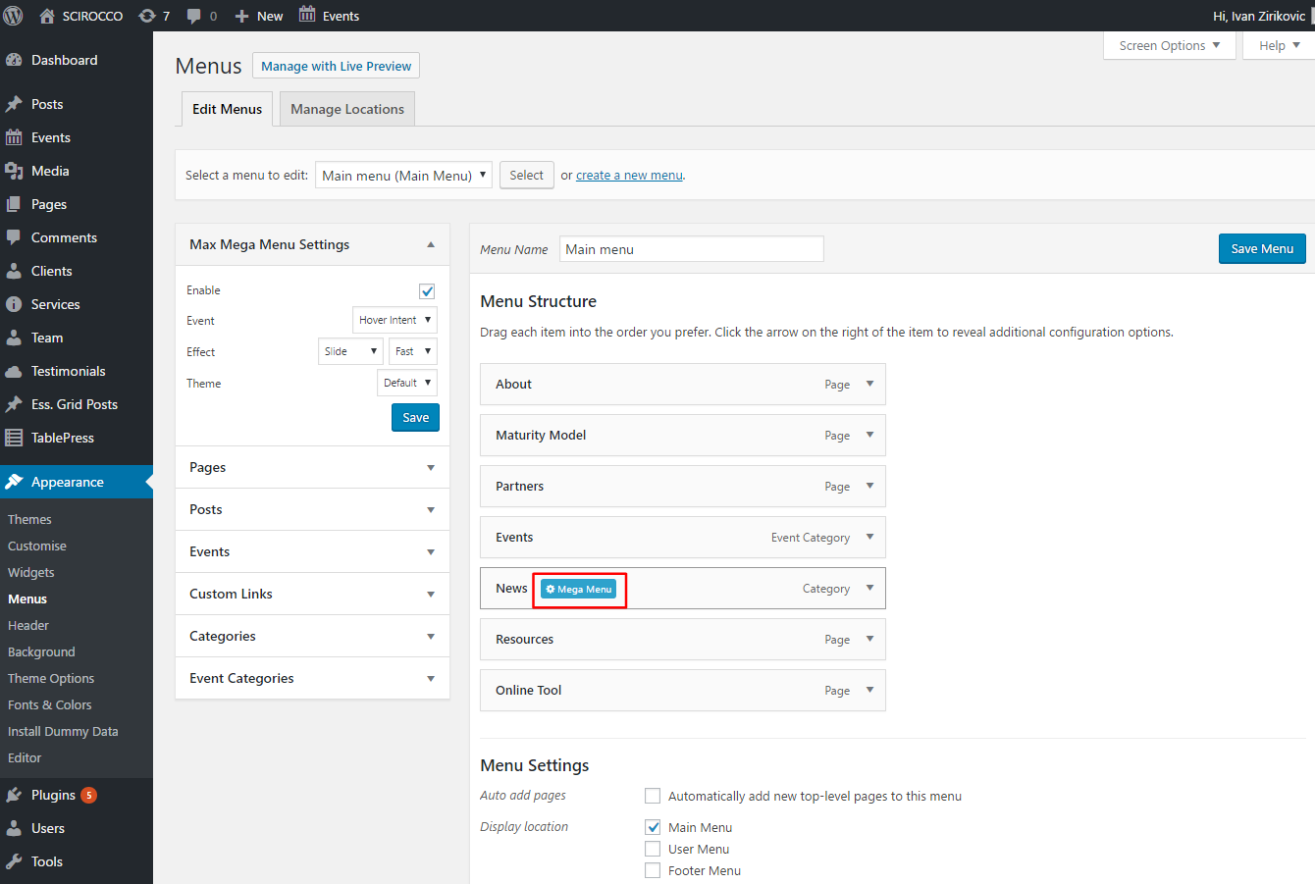

Next, choose these settings:
Sub menu display mode > Mega Menu
Select Widget to add to the panel > Image widget + Text
Select 4 columns grid

By clicking on the arrows in the widgets, you can select their width, but for the optimal display, select 1/4 for Image and 3/4 for Text

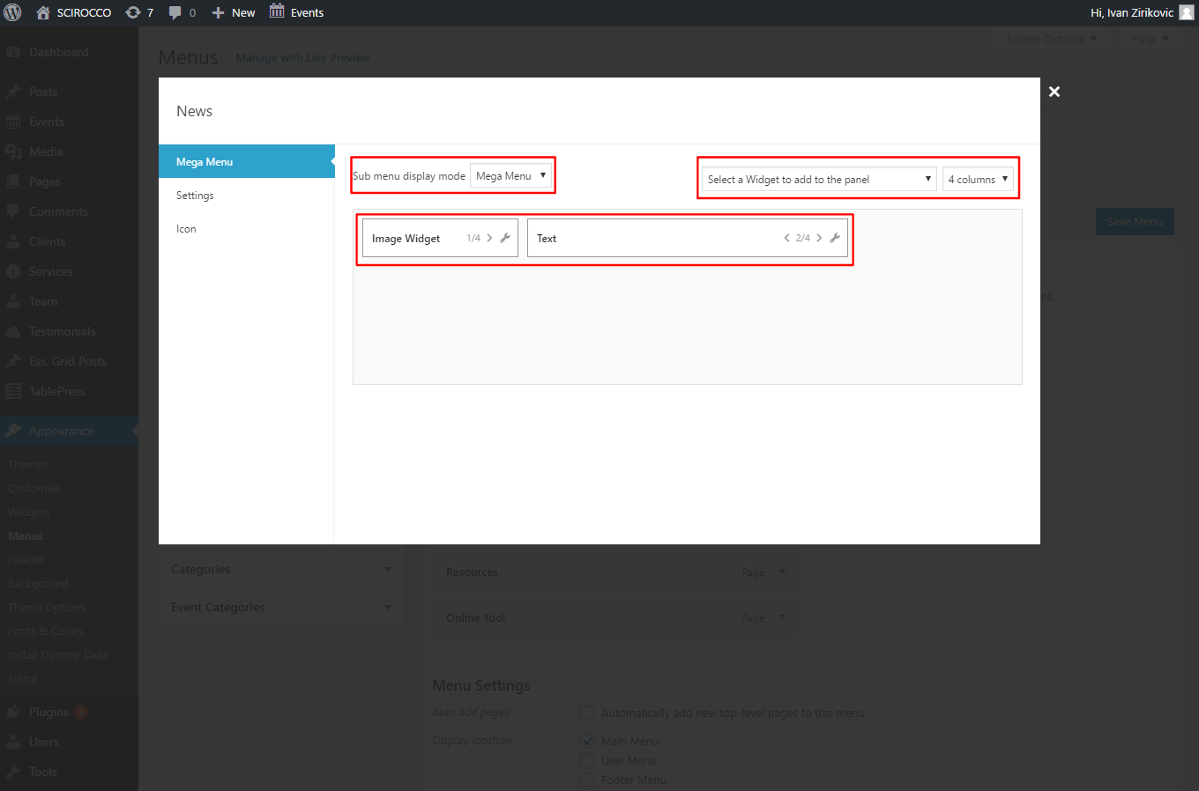

To edit Widget contents follow the steps previously described here.

