How to show upcoming events on the Homepage
In this part of the Wordpress manual, you will learn how to edit the News / Events section.
In order to showing only News on the Homepage instead of Twitter feed, replace this code block
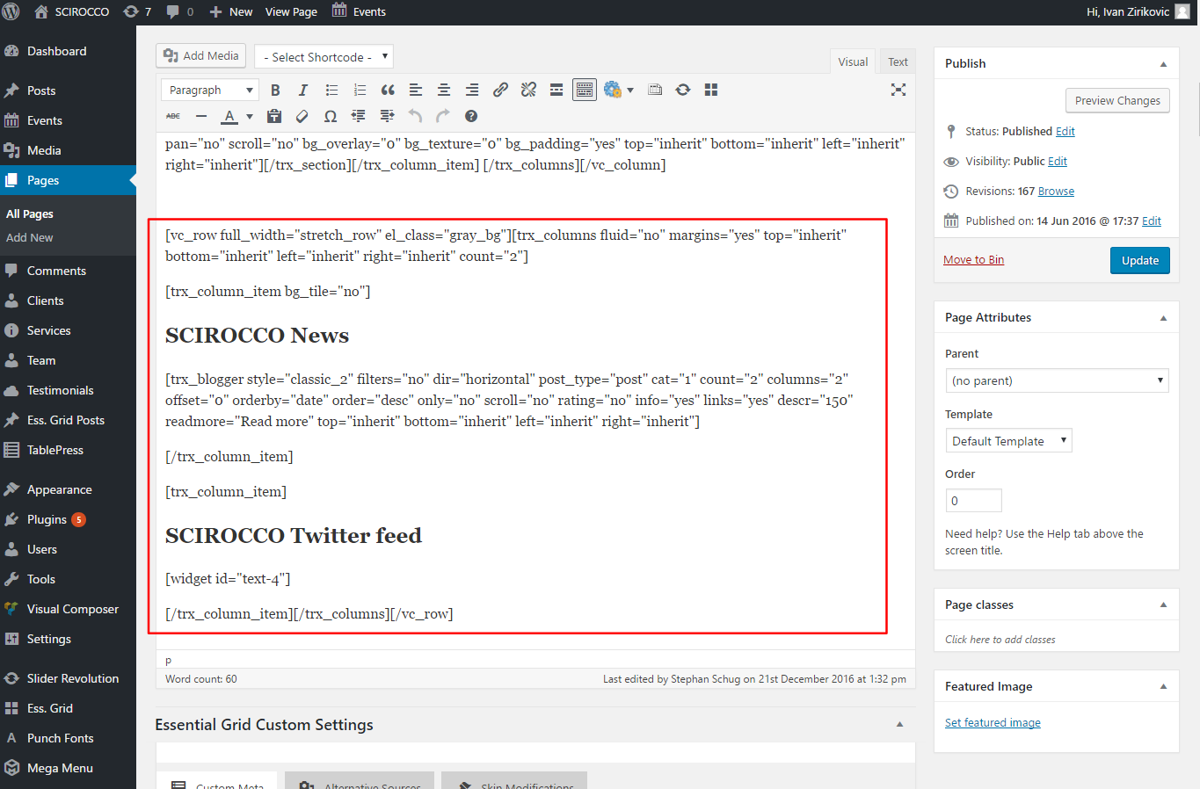

With this one

[vc_row full_width="stretch_row" el_class="gray_bg"]

[trx_columns fluid="no" margins="yes" width="100%" height="100%" top="inherit" bottom="inherit" left=" inherit" right="inherit" count="1"]

[trx_column_item bg_tile="no"]

SCIROCCO News

[trx_blogger style="classic_2" filters="no" dir="horizontal" post_type="post" cat="1" count="3" columns="3" offset="0" orderby="date" order="desc" only="no" scroll="no" rating="no" info="yes" links="yes" descr="150" readmore="Read more" top="inherit" bottom="inherit" left="inherit" right="inherit"]

[/trx_column_item]

[/trx_columns]

[/vc_row]

By doing so, the last 3 Events will be displayed:
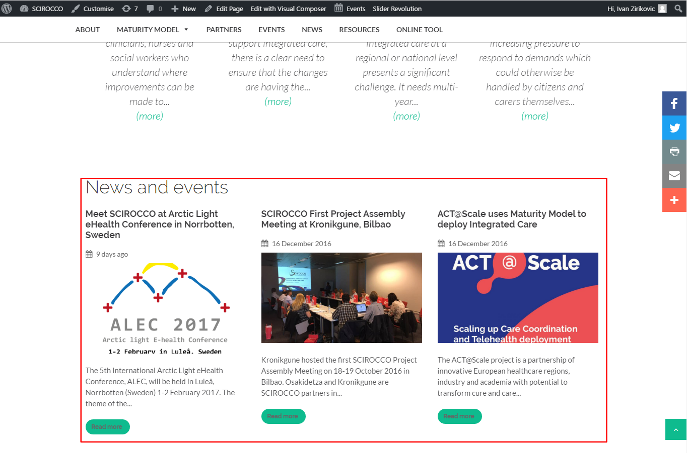

TIP: If you want 4-column news just replace count="3" columns="3" with count="4" columns="4"
NOTE: If there are no valid/active events to be displayed in all columns, they will remain empty.
